Experiment #4 – Transistor AC Amplifier

# Youssef Samwel, Nicolas Sayed, Brandon

# [yo800238@ucf.edu](mailto:yo800238@ucf.edu)

# EEE3307 Electronics I

Section 0014

# Due Date 10/30/2023

# **Project Description**

The objective of this experiment was to construct and analyze amplification circuits based on transistors. The primary aim was to familiarize students with transistor biasing, bias stability, Q-point, and AC load line.

# **2.0 About Laboratory Day and Equipment List**

# The laboratory session took place on the Monday section between 6:00pm and 8:50pm on October 16/23, 2023. My lab partners were Nicolas and Brandon. The equipment for the is experiment is listed below,

1. Tektronix MSO 4034 Oscilloscope
2. Tektronix AFG3022 Function Generator
3. 2N2222 NPN BJT Transistor
4. Rohde & Schwarz HMC 8012 Digital Multimeter

# **3.0 Pre-Laboratory Question and Simulation (SPICE)**

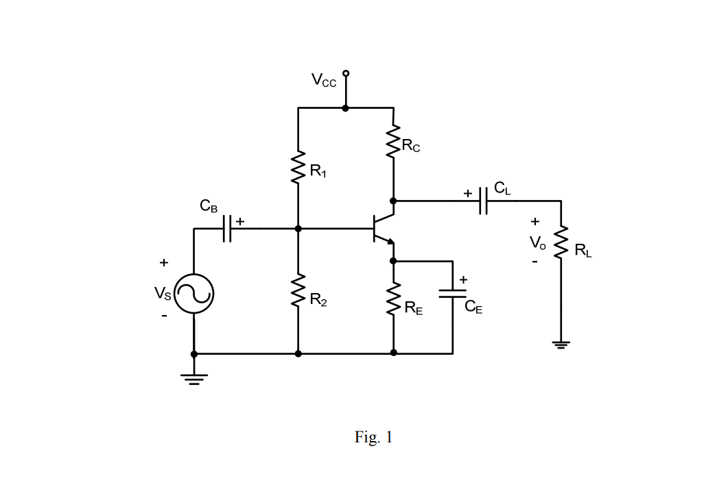

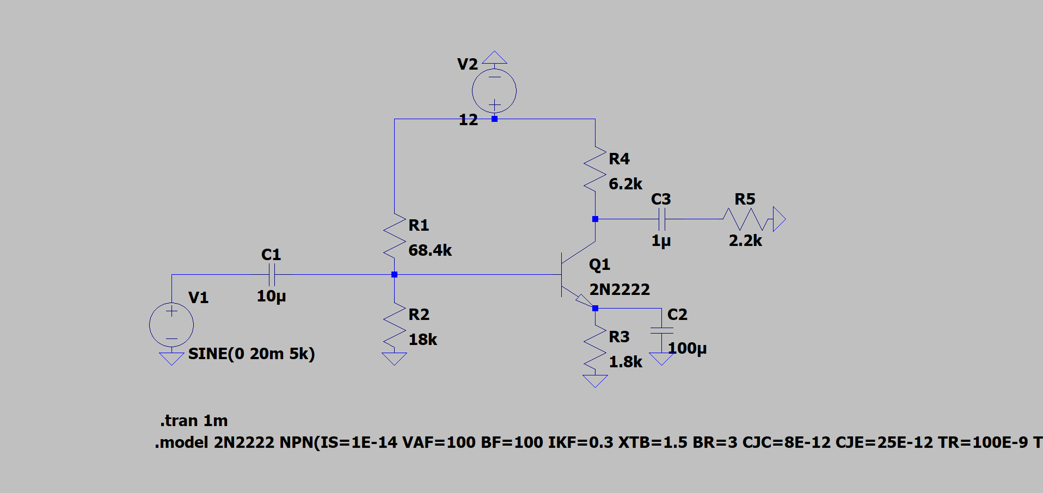

Simulation Circuit in LTspice

Let VCC = 12 V, RC = 6.2 kΩ, RE = 1.8 kΩ, and RL = 2.2 kΩ.

1) Calculate values of R1, R2 so that ICQ ≈ 1 mA and for good bias stability (or RBB =0.1×(β+1)×RE).

$$R_{BB}=\frac{\left(β+1\right)R_{E}}{10}$$

$$V_{BB}=V_{BE}+I_{CQ}(\frac{R_{BB}}{β})$$

By choosing the value for R1 we can determine the value for R2 by using the following formula,

$$R_{2}=-\frac{R_{1}V_{BB}}{V_{BB}-V_{cc}}$$

If we choose R1 to be 68.4 kΩ we can compute R2 to be 18 kΩ.

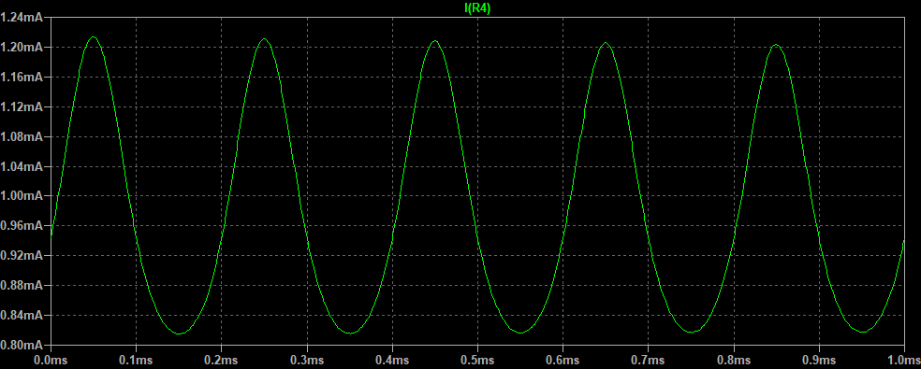

Simulation for Question 1

2) Compute the Q-point and the maximum unclipped output voltage with CE included (CE = 100µF).

The Q-point is (4-volt, 1 mA). The maximum output voltage can be computed by $V_{cutoff}=V_{CEQ}+I_{CQ}*(R_{C}//R_{L})$ which is 6.84V.

3) Repeat 2 if capacitor CE is removed.

The cut off voltage when CE is removed is 3.24V.

4) With RC, RE and RL the same as what used in 1), re-calculate R1 and R2 so that the operating point is at the center of the AC load line. Re-calculate the maximum unclipped output with CE included (CE = 100 µF).

R1 = 84.6kΩ and R2 = 18kΩ

5) Repeat 4 with the bypass capacitor CE removed.

R1 = 84.6kΩ and R2 = 18kΩ

6) Change the value of RC to 3.2 kΩ and re-calculate the DC operating point ICQ. What do you notice?

The ICQ value returns to 1mA when RC changes to 3.2kΩ.

# **4.0 Experiment Procedure**

2) Measure the maximum sinusoidal unclipped output. Set the input frequency to 5 kHz.

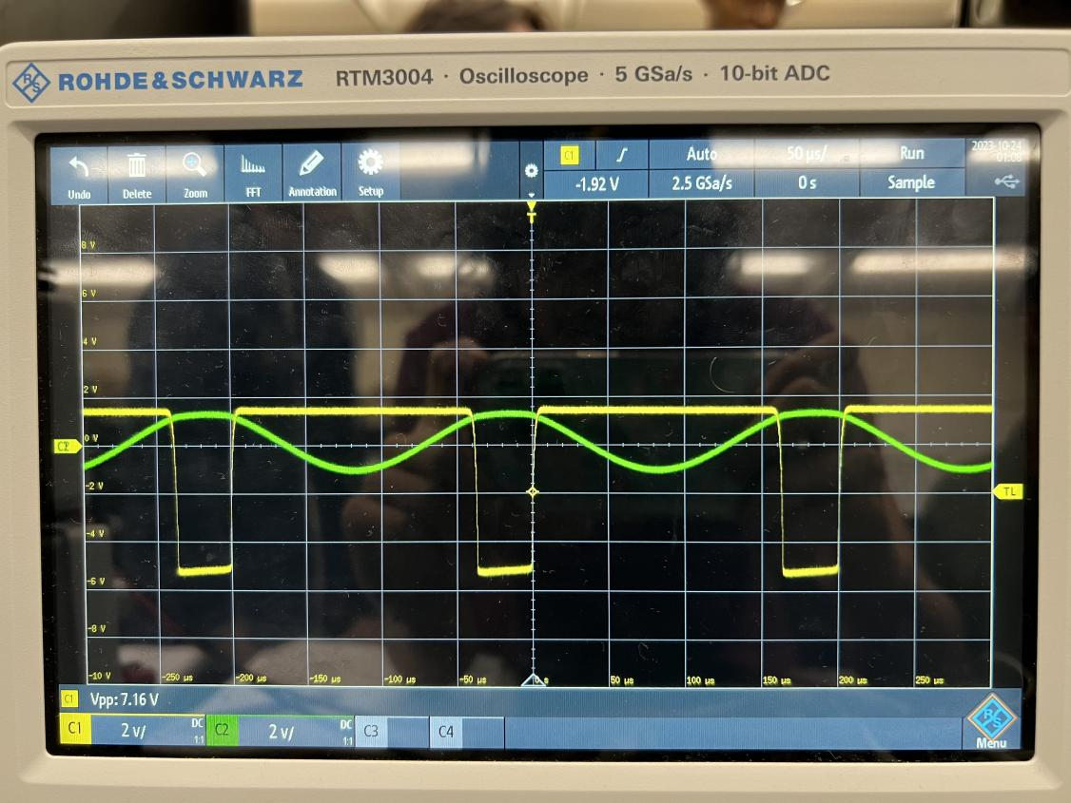

3) Repeat (2) with CE removed.

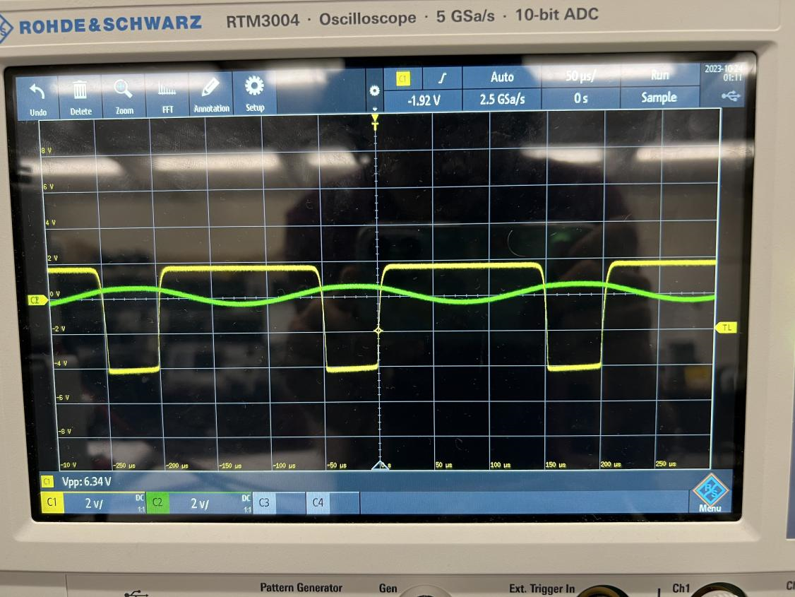

4) Replace R1, R2 with the ones found in the pre-lab preparation part (4) and measure the new unclipped output.

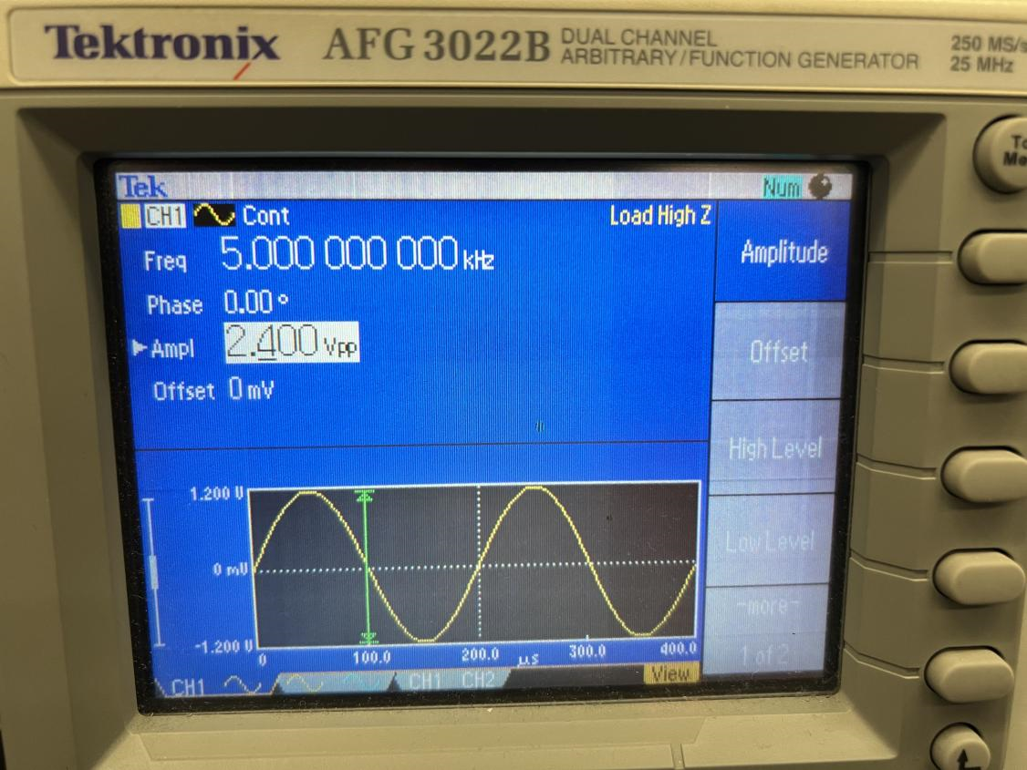

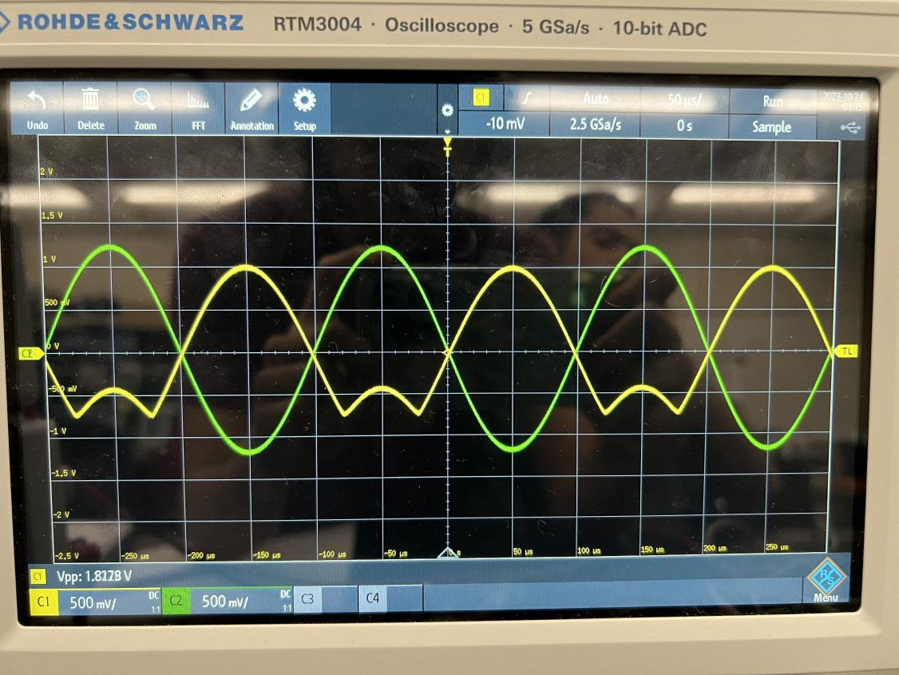

5) Repeat (4) with CE removed.

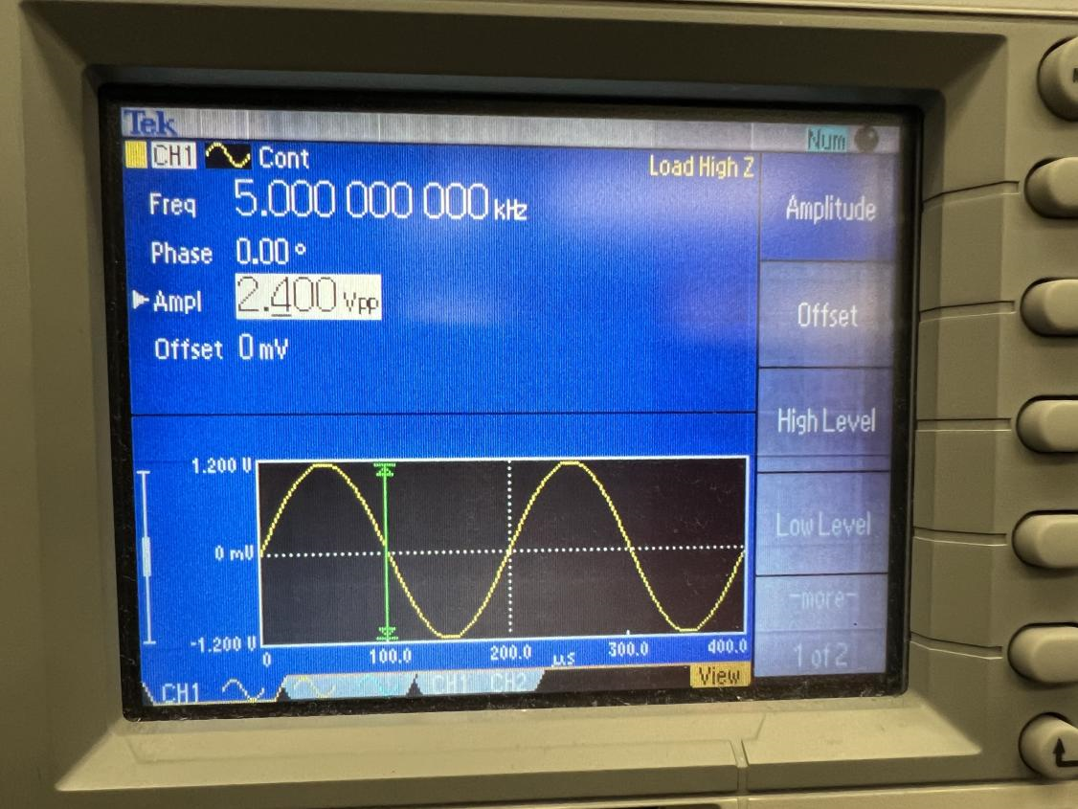

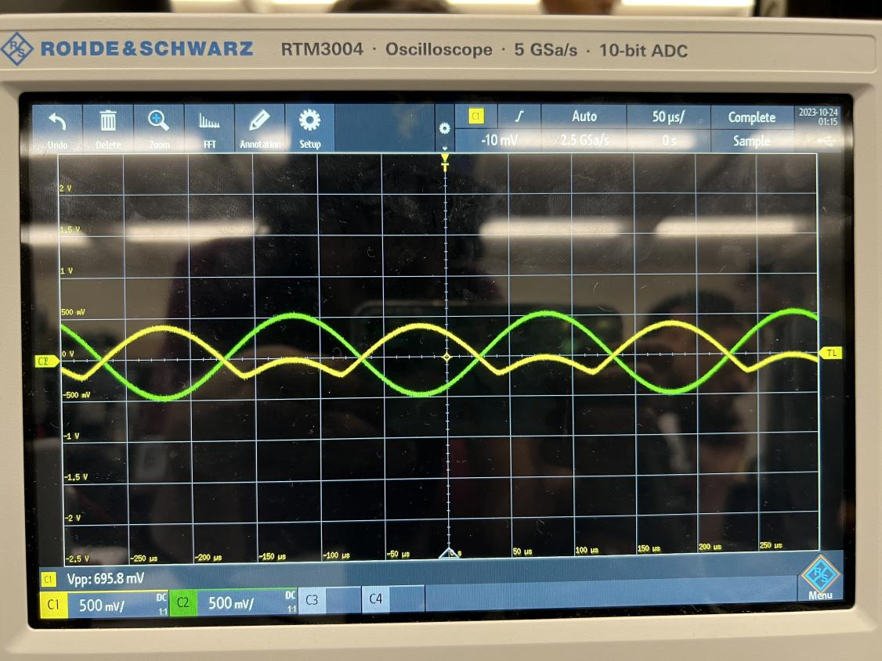

6) Change RC to 3.2 kΩ and measure ICQ after the change

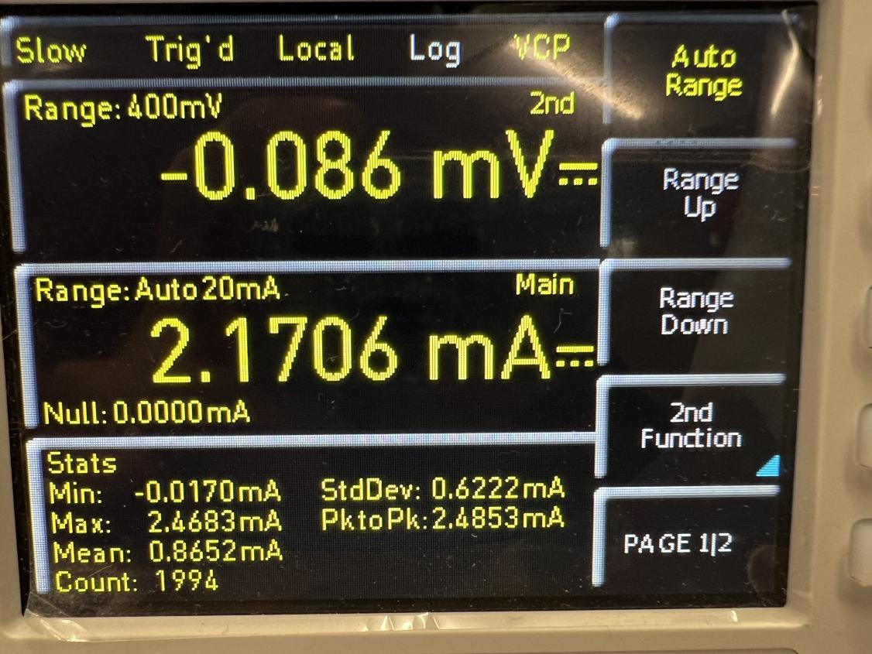.

# **5.0 Learned Objectives**

* Transistor Biasing
* DC Load Line Analysis
* AC Load Line Analysis
* Transistor Amplification
* Small AC Signal Analysis

# **6.0 Conclusion**

In summary, the experiment can be considered a success, as the observed outcomes closely aligned with the anticipated results derived from prelab calculations and SPICE simulations of the amplifiers. While some challenges were encountered during the circuit construction phase, these were successfully addressed by the conclusion of the lab. The variation in amplifier behavior at different input voltages provided intriguing insights. Lower input voltages resulted in well-amplified outputs with minimal distortion and no clipping yet exploring the amplifier's maximum output capacity revealed complex and convoluted waveforms. This disparity shed light on the underlying principles governing BJT amplifiers, even though a notable conceptual gap remained in calculating these maximum outputs, leaving a sense of dissatisfaction. On the other hand, the impact of a bypass capacitor on output became clearer, even if the underlying rationale remains somewhat ambiguous. Ultimately, this experiment served as an invaluable learning experience, highlighting the versatility and utility of amplifiers across diverse applications, if they are operated within their designated parameters.